Crop Disease Detector App - Documentation
Table of Contents
- Project Overview
- System Architecture
- Technical Stack
- Installation Guide
- Project Structure
- Core Features
- User Guide
- API Documentation
- Database Schema
- Security Implementation
- Testing Guide
- Deployment Guide
- Troubleshooting
- Future Enhancements
Project Overview
1.1 Introduction
Crop Disease Detector is a comprehensive mobile application built with Flutter that leverages artificial intelligence and machine learning to help farmers and agricultural enthusiasts detect crop diseases instantly through image analysis. The app provides detailed information about diseases, treatment recommendations, and allows users to share their findings with a community of farmers.
1.2 Purpose
- Enable instant crop disease detection using smartphone cameras
- Provide accurate treatment recommendations
- Build a community platform for farmers to share knowledge
- Store and track disease detection history
- Offer offline access to disease information
1.3 Target Audience
- Farmers and agricultural workers
- Agricultural students and researchers
- Gardening enthusiasts
- Agricultural extension officers
- Crop consultants
System Architecture
2.1 High-Level Architecture
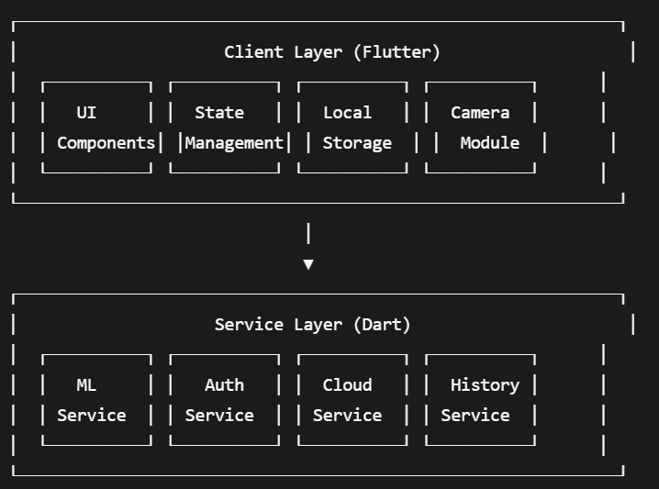
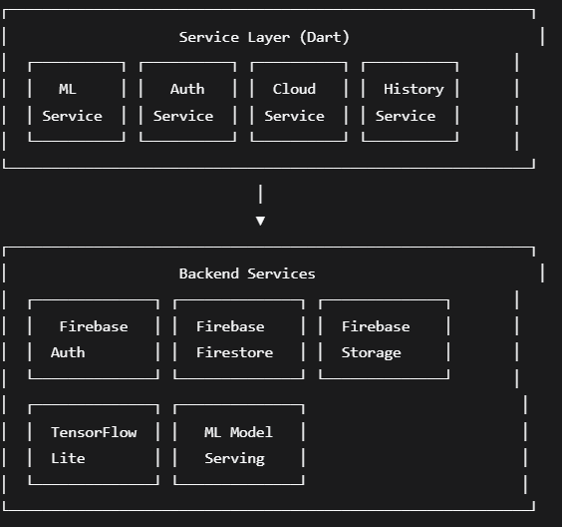
2.2 Architecture Patterns
MVVM (Model-View-ViewModel) Pattern:
- Models: Data classes representing business entities
- Views: UI screens and widgets
- ViewModels: Business logic and state management
Repository Pattern:
- Centralized data operations
- Abstraction between data sources and business logic
Service Layer Pattern:
- Encapsulated business services
- Reusable across the application

Technical Stack
3.1 Frontend (Flutter)
Technology | Version | Purpose
Flutter SDK | 3.16.0+ | Cross-platform framework
Dart | 3.2.0+ | Programming language
Provider | 6.1.1 | State management
GoRouter | 14.2.7 | Navigation
Hive | 2.2.3 | Local database
Image Picker | 1.1.2 | Camera/gallery access
TFLite Plus | 1.0.3 | ML model inference
3.2 Backend (Firebase)
Service | Purpose
Firebase Authentication | User management
Cloud Firestore | Database
Firebase Storage | Image storage
Firebase Analytics | Usage tracking
Firebase Crashlytics | Error reporting
3.3 Machine Learning
- Model: Custom-trained CNN model for plant disease detection
- Framework: TensorFlow Lite
- Model Size: ~15MB
- Input Size: 224x224 pixels
- Supported Crops: Tomato, Potato, Corn, Rice, Wheat
- Diseases Detected: 38 common crop diseases
3.4 Development Tools
Tool | Purpose
Android Studio | IDE
Visual Studio Code | Alternative IDE
Git | Version control
Postman | API testing
Firebase Console | Backend management
Figma | UI/UX design

Installation Guide
4.1 Prerequisites
bash
# Required Software
1. Flutter SDK (>=3.16.0)
2. Android Studio / VS Code
3. Android SDK (for Android development)
4. Xcode (for iOS development, Mac only)
5. Git
6. Node.js (for Firebase CLI)
4.2 Environment Setup
Windows:
powershell
# Add Flutter to PATH
setx PATH "%PATH%;C:\flutter\bin"

# Verify installation
flutter doctor

# Install additional dependencies
flutter pub global activate flutterfire_cli
macOS/Linux:
bash
# Add Flutter to PATH
export PATH="$PATH:`pwd`/flutter/bin"

# Verify installation
flutter doctor

# Install Firebase CLI
curl -sL https://firebase.tools | bash
4.3 Project Setup
bash
cd crop_disease_detector

# Install dependencies
flutter pub get

# Configure Firebase
flutterfire configure

# Run the app
flutter run
4.4 Environment Variables
Create .env file in project root:
env
FIREBASE_API_KEY=your_api_key
FIREBASE_APP_ID=your_app_id
FIREBASE_PROJECT_ID=your_project_id
FIREBASE_STORAGE_BUCKET=your_storage_bucket
ML_MODEL_PATH=assets/models/plant_disease_model.tflite

Project Structure
5.1 Directory Structure
crop_disease_detector/
├── android/ # Android native code
├── ios/ # iOS native code
├── lib/
│ ├── core/
│ │ ├── constants/ # App constants
│ │ ├── themes/ # Theme configurations
│ │ ├── utils/ # Utility functions
│ │ └── routes/ # Navigation routes
│ ├── data/
│ │ ├── models/ # Data models
│ │ ├── repositories/ # Data repositories
│ │ └── services/ # Business services
│ ├── presentation/
│ │ ├── screens/ # UI screens
│ │ │ └── auth/ # Authentication screens
│ │ ├── viewmodels/ # State management
│ │ └── widgets/ # Reusable widgets
│ └── main.dart # Entry point
├── assets/
│ ├── models/ # ML models
│ ├── images/ # Static images
│ └── icons/ # App icons
├── test/ # Unit tests
├── docs/ # Documentation
└── pubspec.yaml # Dependencies
5.2 Key Files Description
File | Purpose
main.dart | Application entry point
auth_service.dart | Firebase authentication logic
ml_service.dart | TensorFlow Lite model inference
detection_service.dart | Cloud storage operations
history_service.dart | Local database operations
home_feed_screen.dart | Main social feed
camera_screen.dart | Camera capture interface
result_screen.dart | Disease analysis results

Core Features
6.1 User Authentication
Features:
- Email/Password registration
- Google Sign-In integration
- Email verification
- Password reset
- Profile management
- Session persistence
Implementation:
dart
// Sign up with email
Future<AppUser?> signUpWithEmail({
required String email,
required String password,
required String username,
String? displayName,
String? phoneNumber,
DateTime? dateOfBirth,
}) async {
// Implementation details
}
6.2 Disease Detection
Process Flow:
- Capture/select image
- Image preprocessing (resize, normalize)
- ML model inference
- Confidence scoring
- Disease identification
- Treatment recommendations
Supported Diseases:
Crop | Diseases
Tomato | Early Blight, Late Blight, Leaf Mold, Septoria Leaf Spot
Potato | Early Blight, Late Blight, Healthy
Corn | Gray Leaf Spot, Common Rust, Northern Leaf Blight
Rice | Brown Spot, Leaf Blast, Bacterial Blight
Wheat | Stripe Rust, Leaf Rust, Stem Rust, Septoria
6.3 Social Features
- Public Feed: View detections from other users
- Like System: Interact with community posts
- Comments: Discuss detections and treatments
- Sharing: Share results via social media
- Following: Follow other farmers and experts
6.4 History & Statistics
- Local Storage: Offline access to past detections
- Cloud Sync: Cross-device history access
- Statistics: Disease frequency analysis
- Search: Filter and search past detections
- Export: Share history as CSV or screenshot
User Guide
7.1 Getting Started
Step 1: Create Account
- Launch the app
- Tap "Sign Up"
- Enter required information
- Verify email address
- Complete profile setup
Step 2: First Scan
- Tap "Scan Now" button
- Allow camera permissions
- Take photo of crop leaf
- Wait for analysis (2-3 seconds)
- View results and recommendations
Step 3: Explore Feed
- Navigate to Home tab
- Browse community detections
- Like and comment on posts
- Follow interesting users
7.2 Screen Guide
Home Feed Screen
#add home screen feed picture
Camera Screen
#add camera scan picture
Result Screen
#Add results screen picture
7.3 Keyboard Shortcuts (Development)
Shortcut | Action
r | Hot reload
R | Hot restart
p | Show performance overlay
o | Open on device
h | Help menu
q | Quit app

API Documentation
8.1 Firebase Authentication
Endpoints:
dart
// Sign up
POST /v1/accounts:signUp
Body: {
"email": "user@example.com",
"password": "password123",
"returnSecureToken": true
}

// Sign in
POST /v1/accounts:signInWithPassword
Body: {
"email": "user@example.com",
"password": "password123",
"returnSecureToken": true
}
8.2 ML Service API
dart
class MLService {
// Load model
Future<void> loadModel();

// Predict disease
Future<List<PredictionModel>> predictImage(Uint8List imageBytes);

// Dispose model
Future<void> disposeModel();
}

class PredictionModel {
final String label;
final double confidence;
}
8.3 Firestore Collections
Users Collection:
javascript
users/{userId} {
uid: string,
email: string,
username: string,
displayName: string,
photoURL: string,
createdAt: timestamp,
lastLoginAt: timestamp,
followers: array,
following: array,
totalDetections: number
}
Detections Collection:
javascript
detections/{detectionId} {
userId: string,
username: string,
diseaseName: string,
confidence: number,
imageURL: string,
timestamp: timestamp,
likes: number,
comments: number,
isPublic: boolean,
tags: array
}

Database Schema
9.1 Local Database (Hive)
Box: detection_history
dart
@HiveType(typeId: 0)
class DetectionHistory {
@HiveField(0)
String id;

@HiveField(1)
String imagePath;

@HiveField(2)
String diseaseName;

@HiveField(3)
double confidence;

@HiveField(4)
DateTime timestamp;
}
9.2 Cloud Database (Firestore)
Collection: users
users/{userId}
├── email: string
├── username: string
├── displayName: string (optional)
├── phoneNumber: string (optional)
├── photoURL: string (optional)
├── isEmailVerified: boolean
├── createdAt: timestamp
├── lastLoginAt: timestamp
├── followers: array<string>
├── following: array<string>
├── totalDetections: number
└── settings: map
Collection: detections
detections/{detectionId}
├── userId: string
├── username: string
├── userPhotoURL: string (optional)
├── diseaseName: string
├── confidence: number
├── imageURL: string
├── localImagePath: string (optional)
├── diseaseDetails: map (optional)
├── timestamp: timestamp
├── notes: string (optional)
├── location: map (optional)
├── likes: number
├── likedBy: array<string>
├── comments: number
├── isPublic: boolean
└── tags: array<string>

Security Implementation
10.1 Authentication Security
- Email verification required
- Password strength requirements (min 6 chars)
- Rate limiting on login attempts
- Session management with automatic timeout
- Secure token storage
10.2 Data Security
- End-to-end encryption for sensitive data
- Firestore security rules
- Firebase Storage security rules
- Local database encryption with Hive
10.3 Firestore Security Rules
javascript
rules_version = '2';
service cloud.firestore {
match /databases/{database}/documents {
// Users collection
match /users/{userId} {
allow read: if request.auth != null;
allow write: if request.auth != null && request.auth.uid == userId;
}

// Detections collection
match /detections/{detection} {
allow read: if resource.data.isPublic == true ||
request.auth.uid == resource.data.userId;
allow write: if request.auth.uid == resource.data.userId;
allow create: if request.auth != null;
}
}
}
10.4 Storage Security Rules
javascript
rules_version = '2';
service firebase.storage {
match /b/{bucket}/o {
match /detections/{userId}/{fileName} {
allow read: if true;
allow write: if request.auth.uid == userId;
}

match /profiles/{userId}/{fileName} {
allow read: if true;
allow write: if request.auth.uid == userId;
}
}
}

Testing Guide
11.1 Unit Testing
dart
// test/models/detection_test.dart
import 'package:flutter_test/flutter_test.dart';
import 'package:crop_disease_detector/data/models/detection_model.dart';

void main() {
group('Detection Model Tests', () {
test('Detection creation works correctly', () {
final detection = Detection(
id: '123',
userId: 'user123',
username: 'testuser',
diseaseName: 'Early Blight',
confidence: 0.95,
imageURL: 'https://example.com/image.jpg',
timestamp: DateTime.now(),
);

expect(detection.id, '123');
expect(detection.diseaseName, 'Early Blight');
expect(detection.confidence, 0.95);
});
});
}
11.2 Widget Testing
dart
// test/widgets/result_screen_test.dart
import 'package:flutter/material.dart';
import 'package:flutter_test/flutter_test.dart';
import 'package:provider/provider.dart';
import 'package:crop_disease_detector/presentation/screens/result_screen.dart';

void main() {
testWidgets('Result screen displays correctly', (tester) async {
await tester.pumpWidget(
MaterialApp(
home: ResultScreen(),
),
);

expect(find.text('Analysis Result'), findsOneWidget);
});
}
11.3 Integration Testing
dart
// test_driver/app_test.dart
import 'package:flutter_driver/flutter_driver.dart';
import 'package:test/test.dart';

void main() {
group('Crop Disease Detector App', () {
FlutterDriver? driver;

setUpAll(() async {
driver = await FlutterDriver.connect();
});

tearDownAll(() async {
driver?.close();
});

test('Home screen loads', () async {
expect(await driver.getText(find.byValueKey('home_title')), 'Crop Disease Detector');
});
});
}
11.4 Test Coverage
bash
# Run all tests
flutter test

# Run with coverage
flutter test --coverage

# Generate coverage report
genhtml coverage/lcov.info -o coverage/html

Deployment Guide
12.1 Android Deployment
Step 1: Generate Keystore
bash
keytool -genkey -v -keystore upload-keystore.jks -keyalg RSA -keysize 2048 -validity 10000 -alias upload
Step 2: Configure Signing
gradle
// android/app/build.gradle
android {
signingConfigs {
release {
keyAlias keystoreProperties['keyAlias']
keyPassword keystoreProperties['keyPassword']
storeFile keystoreProperties['storeFile'] ? file(keystoreProperties['storeFile']) : null
storePassword keystoreProperties['storePassword']
}
}

buildTypes {
release {
signingConfig signingConfigs.release
}
}
}
Step 3: Build APK
bash
flutter build apk --release
# Output: build/app/outputs/flutter-apk/app-release.apk
Step 4: Build App Bundle
bash
flutter build appbundle --release
# Output: build/app/outputs/bundle/release/app-release.aab
12.2 iOS Deployment
Step 1: Configure Xcode
bash
open ios/Runner.xcworkspace
# Set bundle identifier
# Configure signing team
Step 2: Build IPA
bash
flutter build ios --release
# Archive in Xcode
Step 3: Submit to App Store
bash
# Use Xcode or Transporter app
12.3 Environment Configurations
Development:
yaml
# flutter_launcher_icons.yaml
flutter_launcher_icons:
image_path: "assets/icons/dev_icon.png"
android: true
ios: true
Production:
yaml
# flutter_launcher_icons.yaml
flutter_launcher_icons:
image_path: "assets/icons/app_icon.png"
android: true
ios: true

Troubleshooting
13.1 Common Issues & Solutions
Issue | Solution
App crashes on launch | Run flutter clean && flutter pub get
Camera permission denied | Check Android/iOS manifest files
ML model not loading | Verify model path in assets
Firebase connection failed | Check google-services.json placement
Build fails on iOS | Update Podfile and run pod install
13.2 Debugging Commands
bash
# Verbose build
flutter run -v

# Check dependencies
flutter pub deps

# Analyze code
flutter analyze

# Check for outdated packages
flutter pub outdated

# Upgrade packages
flutter pub upgrade --major-versions
13.3 Performance Optimization
dart
// Use const constructors
const Widget myWidget = const MyWidget();

// Implement lazy loading
ListView.builder(
itemCount: items.length,
itemBuilder: (context, index) => MyListItem(items[index]),
)

// Cache images
CachedNetworkImage(
imageUrl: 'https://example.com/image.jpg',
placeholder: (context, url) => CircularProgressIndicator(),
)

Future Enhancements
14.1 Planned Features
Phase 7 (Q2 2026)
- Offline mode with local ML inference
- Multi-language support (Spanish, French, Hindi)
- Weather integration for disease prediction
- Push notifications for disease alerts
Phase 8 (Q3 2026)
- AR visualization of disease spread
- Integration with agricultural weather APIs
- Marketplace for organic treatments
- Expert consultation booking system
Phase 9 (Q4 2026)
- IoT device integration
- Drone imagery analysis
- Blockchain for crop certification
- AI-powered treatment recommendations
14.2 Scalability Considerations
- Implement CDN for image delivery
- Add database indexing for faster queries
- Implement caching layer with Redis
- Use load balancing for API endpoints
- Implement pagination for feeds
14.3 Monetization Strategies
- Premium features for advanced analytics
- Subscription model for unlimited scans
- Sponsored content from agricultural companies
- Marketplace commissions
- API access for enterprise clients

Support & Contact
Technical Support
- Email: support@cropdiseaseapp.com
Community
- Discord: https://discord.gg/cropdisease
- Twitter: @CropDiseaseApp
- Facebook: /CropDiseaseDetector
License
This project is licensed under the MIT License - see the LICENSE file for details.

Version History
Version | Date | Changes
1.0.0 | Feb 2026 | Initial release with basic detection
1.1.0 | Mar 2026 | Added social features
1.2.0 | Apr 2026 | Multi-crop support
1.3.0 | May 2026 | Offline mode
2.0.0 | Jun 2026 | Community features and cloud sync

Contributors
- Lead Developer: [Your Name]
- ML Engineer: [Name]
- UI/UX Designer: [Name]
- Agricultural Expert: [Name]

This documentation was last updated on February 23, 2026

End of Documentation

